Do You Know How to Study Effectively



Study smarter not harder

Once again exams are approaching and students should be studying (keyword being should). However, what works well for one student, might not be the right method for another. People learn and study in various ways and it is important to know what style suits you best. Effective study habits can be learned to improve the ability of **studying smarter.**

Here are ten general study tips that can help (regardless of your method).

1. Develop a study routine and stick to it.

An important part of having a successful daily routine is to have realistic goals and set deadlines. Without a deadline you will not be motivated to do the work on time. It is helpful to know your study habits and have an overview of your grades. Questions to ask yourself are: When do you usually study and for how long? Are you satisfied with your grades? With which subjects are you having most difficulty? What are your personal priorities and commitments? Reflecting on these questions will help in creating a study plan, keeping organized and maintaining better focus on work that needs to be done. It is advisable to have a written study schedule (in a calendar, planner) with all the exam dates and assignment deadlines highlighted.

Remember, research has repeatedly demonstrated how spacing out study sessions over a longer period of time improves our long-term memory. I.e. if you have around 16 hours to spend on a subject, it would be better to study it for four hours each week for four weeks rather than cram all 16 hours in the last day or two.

2. Color code it, write out notes, and create mental maps.

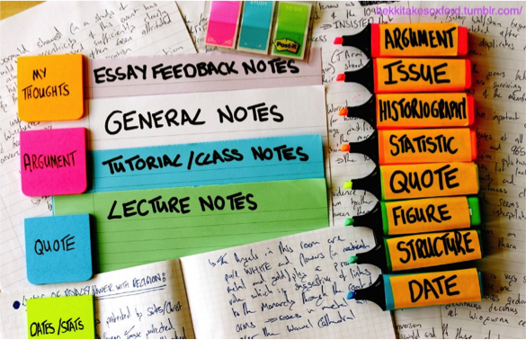  
Connecting is a vital part of learning. Studying using a highlighter helps you make connections visually, not just mentally. Also, you learn by doing- rewriting notes, creating drawings, diagrams, mental maps or study cards. Visualizing information that is difficult to describe (concepts that build upon the understanding of one another) will create a visual memory to recall during an exam. Also use mnemonics, memory tricks that aid information retention by becoming associated with something more meaningful/relatable. Mnemonics can be acronyms, memorable phrases, images, spelling mnemonics, rhymes, etc. Remember how you learned the alphabet by singing the ABC’s? That’s a music mnemonic. Knowing what type of exam it will be can also help. If it is multiple choice, you will probably need to work fast, know definitions, years, and concepts. On the other hand, essay type exams focus on overall understanding and connecting learned material, often through examples (which you can also try to prepare in advance).

3. Turn off all digital distractions.

This includes phone calls, texts, emails, and social media altogether (Facebook, WhatsApp, Snapchat, Instagram, Skype, Viber, etc.). It would be most effective to leave your device in another room. If you cannot limit the distractions then deleting the apps and reinstalling them later can also be an option. Furthermore, there are apps like Antisocial, which can block social media for a scheduled period of time. Other apps such as Freedom or Off Time can block Internet altogether for a set time, both for phones and computers. Declare your study time a Wi-Fi and gadget-free zone.

4. Find the right place to study.

  
One of the best places to study effectively is the library. Only whispers are tolerated and you will be asked to mute your phone. The atmosphere itself can highly motivate you. When you are surrounded by a lot of focused people who are there to learn, chances are you will want to be part of that movement. Also, a good library will offer you all the resources to study, such as research tools, help with references or borrowing a book for your class. The library can become your quiet study oasis.

However, if you chose to study at home make sure you limit all distractions (parents, siblings, friends, internet, TV, phone, video games, etc.). Keep your study area clean because a clean space helps you think clearly and focus, and you will not be wasting time on finding your things. Also, it is advisable not to work from bed since the temptation to sleep (especially if you are sleep deprived) will be too appealing. Instead, have a good, comfortable chair that promotes a healthy posture. Student lounges, study halls or quiet coffee houses are also an option, but make sure to choose quiet areas and not loud central gathering places.

5. Schedule breaks.

Your studying schedule should have the time you plan to start studying, at what times you will take breaks, and the time you intend to finish. Setting regular breaks into your study schedule will help you stay focused on the task and can eliminate the feeling of burnout. It is also a good way to reward yourself by taking time away from your workload. It is advisable to take a 5- minute break every 25 minutes or larger breaks after every 90 or 120 minutes of uninterrupted studying. Breaks that are too long (exceeding half an hour) can lead to the procrastination trap. Also remember that breaks need to be used for relaxation and recharging, not for more tasks.

6. Put yourself to the test.

Quizzing oneself can be one of the best ways to prepare for the real deal. Complete a mock test (sometimes provided by professors or online) or answer those questions at the end of chapters in text books. Recite the information aloud from memory and try to explain it to yourself. Good advice is to imagine you are teaching someone else. Can you pass on what you have learned? Verbalizing concepts and explaining material to others (instead of continuously just reading it) helps reinforce ideas and improves knowledge retention.

7. Establish a study partner or a study group.

For some students, studying by themselves, especially for longer periods of time, can become very monotonous. Pick a study buddy with a similar academic aptitude or, if forming a group, make sure to keep it small (preferably no more than 6 people). Studying with others can increase motivation, help you gain new perspectives, learn new study skills, fill in learning gaps, and learn faster. Study groups can also serve as a great review session before the final exam.

8. Turn off your computer every night.

If you are working on your computer shutting it down will give you a feeling of closure to your day. Also, you will ensure your work is saved and you won’t feel like you are in eternal work mode.

9. Sleep.

The amount of sleep you get will determine how well you are able to stay attentive. If you are sleep deprived you will have a hard time focusing while attempting to study. Besides, while you sleep the brain uses this time to reactivate and reorganize recently learned material. More specifically, memory consolidation takes place during sleep through the strengthening of the neural connections. It is assumed that specific characteristics of brainwaves during different stages of sleep help with the formation of particular types of memory.

10. Be positive.

  
Sometimes how you approach something matters almost as much as what you do. Being in the right mindset includes believing in yourself. You can be a bit anxious before exams, and the stress can increase as the exam date approaches, but it should all become manageable as you sit down and write your answers. The main cause of serious exam anxiety is being poorly prepared. Other causes can be if you’re a perfectionist (anything below “A” grade isn’t acceptable), you had a very bad experience in a previous exam, if you are generally an anxious person, or aren’t physically feeling well. Becoming aware of what causes your anxiety will help to reduce the stress. Also, try avoiding catastrophic thinking, full blown panicking, and most important of all – start studying on time.